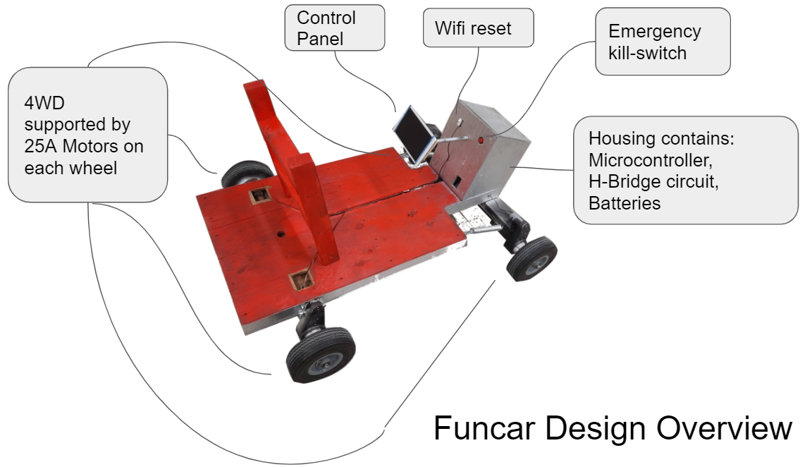Electric Fun Car  
Ryan Laxdal- Diego Montpetit – Gary Coffin

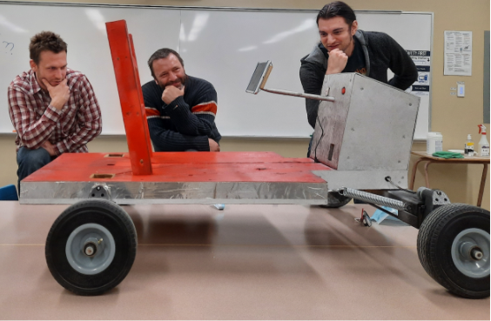



The electric fun car is a 4 wheel drive electric car built for children. What sets this car aside from other children’s vehicles is that the steering wheel and gas pedal are replaced by a GUI (Graphical User Interface)! To operate the vehicle, the user chooses inputs on the GUI, the GUI sends the information wirelessly to a microcontroller. The microcontroller interprets these signals using C++ language and passes the interpreted signals to our H-Bridge controller. Then the H-Bridges allow current to flow from the 12V to the motors as requested by the user.